PART 7 : RULES OF KOBUDO
To achieve their goals, the European Goju-Ryu Karate-Do Federation (EGKF) and the World Goju-ryu Karate-do Federation (WGKF) will follow the direction, rules and objectives established and approved by the international association of Ryukyu Kobudo Hozon Shinko Kai (RKHSK) Okinawa, Japan.

CHAPTER 19 : GENERAL RULES OF KOBUDO
ARTICLE 81: GENERAL MATTERS

81.1 The Kobudo Individual Competition will use a “Point System” and the winner will be the one with the highest total score. The RKHSK Executive Committee may change from a “Points System” to a “Flag System”.

81.2 Kobudo competitions will be organized in individual and team divisions.
Kobudo kata competitions can be individual and team. Team matches consist of competitions between teams of 3 participants each. Each team can be male, female or mixed (2+1). Individual kata competitions consist of individual performances in separate men's and women's divisions.

The RKHSK (PART 7, chapter 24, art. 94-101) may be used in kobudo competitions.
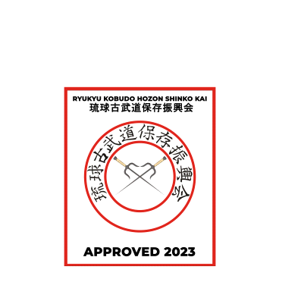
All participants performing in Kobudo must go through the official registration of their weapons.
The traditional weapon must correspond to the size (length, width) and weight according to Appendix 10
After registration, each type of weapon must have the RKHSK mark on it. KOBUDO APPROVED of the respective year.

81.4 Competitors may only perform traditional kata
Okinawan and Japanese Kobudo kata from the RKHSK list of kobudo kata.
Free styles of kobudo kata that are not included in the traditional ones are strictly prohibited.

81.5 Kobudo competitions must be conducted as an open style competition, with each competitor maintaining their own style of kobudo.
Each participant has the right to voluntarily choose a kata from the official list of RKHSK kata kobudo. At the same time, the participant must strictly adhere to the form of both his own practiced style (direction) of kobudo and the chosen style (direction) of kobudo.
- Eligible kata for the Junior and Senior Preliminaries, Semi-Finals and Finals must be selected from Appendix 1 of the official RKHSK Kobudo kata list at the end of this chapter.
- Eligible long BO katas must be selected from Appendix 2 of the official list of RKHSK kobudo katas for preliminaries, semi-finals and finals.
EKKU long weapon katas must be selected from Appendix 3 of the official list of RKHSK kobudo kata for preliminaries, semi-finals and finals.
Nunchaku short weapon kata must be selected from Appendix 4 of the official RKHSK kobudo kata list for preliminaries, semi-finals and finals.
SAI short weapon katas must be selected from Appendix 5 of the official list of RKHSK kobudo katas for preliminaries, semi-finals and finals.
- Acceptable kata with Tonfa short weapons must be selected from Appendix 6 of the official list of RKHSK kata kobudo for preliminaries, semi-finals and finals.
Kama short weapon kama must be selected from Appendix 7 of the official list of RKHSK kobudo kata for preliminaries, semi-finals and finals.
Tinbe short weapon must be selected from Appendix 8 of the official list of RKHSK kobudo kata for preliminaries, semi-finals and finals.
- Acceptable kata with short Tekko weapons must be selected from Appendix 9 of the official list of RKHSK kobudo kata for preliminaries, semi-finals and finals.

81.6 The competition area is the same as in Kata Karate competitions. If possible, a divided (delimited) wooden floor is preferred.
The competition area must be flat with a safe surface covered with tatami mats or wooden boards. The area of the competition should be 8x8 sq.m. and be bounded on the sides.

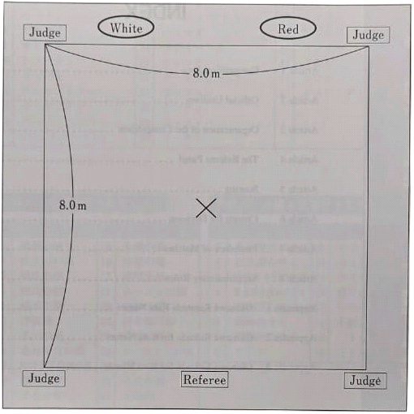

81.7 Uniform: must comply with the conditions set out in article 4 of these rules.
Exception: A black karategi jacket is allowed in kobudo competitions.
An exception is made for kobudo competitors whose uniforms are approved by the OKINAWAN RYUHA (style) and or KAIHA (organization or association). The hakama (skirt) is NOT ALLOWED as it interferes with the judging of the panel of judges.
Hair clips and metal hairpins are NOT allowed, however safety clips are allowed. Any person not obeying these rules may be disqualified.

81.8 All age categories will be held in four divisions:
LONG WEAPONS - "BO", "EKKU".
Each type of demonstrated weapon competes SEPARATELY.
SHORT WEAPONS - NUNCHAKU, SAI, TONFA, KAMA, TINBE and TEKKO.
Each type of demonstrated weapon competes SEPARATELY.
MASTER KOBUDO LONG WEAPONS - Bo , Ekku .
LONG WEAPONS Bo ( Roku Shaku )棍, Ekku エーク
1. ROUND SEMI-FINAL SELECTION: Bó ( Roku Shaku _ _
2. ROUND SEMI FINAL: Bó ( Roku Shaku _ _
3. ROUND FINAL: Ekku エーク
MASTER KOBUDO SHORT WEAPONS - Tekko , Nunchaku , Tonfa , Tinbe , Kama and Sai .
SHORT WEAPONS
1. ROUND SEMI-FINAL SELECTION: Tekko 鉄甲, Nunchaku ヌンチャク,
2. ROUND SEMI FINAL: Tunfa トゥンファー, Tinbe ティンベー
3. ROUND FINAL: Kama , Sai 釵
ARTICLE 82: COMPETITION DECISION
82.1 A panel of judges (1 Center Judge and 4 or 6 Corner Judges) will decide on each Kobudo match.
- Before the competition, the chairman of the Referee Council appoints a panel of judges of 5 or 7 judges.
- In addition, recorders and announcers are appointed to serve the competition.
- Teams representing OKINAWAN RYUHA (style) and or KAIHA (organization or association) MUST provide 2 judges each .

82.2 All competitions must be held solely at the direction of the Center Referee.

The center referee and each corner referee must have a scoreboard (scoreboard ) and two flags (red and white).

82.4 In the “Flag System”, when the Center Referee calls Hantei , victory will be decided by majority based on the Judgment Table (see Diagram 8).

ARTICLE 83: STARTING KOBUDO

83.1 Before each round, the competitors must report the name of the Kobudo kata they will be performing to the Jury Table for it to be recorded on the official sheet.

83.2 Competitors may not repeat the same kobudo kata performed in the previous round.
Exception: see category of children's kobudo and st.88 and category of cadets of kobudo st.89

83.3 When called by the Announcer, the contestant immediately enters the match area, bows to the Center Judge, and clearly announces the name of the Kobudo kata he will be performing in front of the Judges.

83.4 The center judge will clearly repeat the name of the Kobudo kata.

83.5 After that, the competitor will start his performance and at the end will wait for the decision of the Judge.
ARTICLE 84: COMPLETION OF THE KOBUDO KATA

84.1 At the conclusion of the Kata, the Center Judge shall call " Hantei " for decision by the Corner Judges. Immediately and simultaneously, the Center Referee and the Corner Referees will raise their Scoreboards with their decisions. The Calling Announcer must clearly announce the results of the Center Judge and each Corner Judge on the dictaphone.

84.2 The Registrar must record the announced scores on the proper form and calculate the final score as follows: of the five (seven) points received, the highest and lowest scores must be deleted and the remaining three (five) points must be added up.

84.3 The caller Announcer shall clearly announce the total score.

84.4 After the announcement of the total score, the participant bows to the Center Referee and leaves the match area.

ARTICLE 85: ROUNDS

85.1 The Kobudo competition will be organized in two rounds: Round 2 and Round 3 (Final). In categories with more than 16 entries, it will be organized in three rounds: Round 1 (score: 5.0-7.0), with the 12 highest scoring entries advancing to the 2nd round.

85.2 If there are fewer than 16 entries in the first round, then round 1 may be skipped.

85.3 Second Round (Score: 6.0 - 8.0): The highest 6 points will advance to the Final.

85.4 The list of participants in the second round will be in the same order as in the list for the first round.

85.5 Third Round (Final) (Score: 7.0-9.0): The Kobudo kata in the Final must be different from the Kobudo kata performed in the 2nd round. Exception : See ARTICLE 83.2.
83.2 Competitors may not repeat the same kobudo kata performed in the previous round.
Exception: children 6-7 years old, 8-9 years old; children 10-11 years old

85.6 The electronic list will establish the order in which each competitor will compete in the Final Round.

ARTICLE 86: DRAW

86.1 In the event of a draw in the 1st or 2nd round, to determine the list of participants for the next round, the minimum score of the remaining 3 points (after removing the minimum and maximum points) will be added to the total points for that round. Removed points will not count towards any other classification.
86.2 If the draw still remains after this, the maximum score of the remaining 3 points is then added to the total score for that round.

86.3 If the draw continues, the competitors must perform an additional and different kobudo kata from this round. Exception : See ARTICLE 83.2.
83.2 Competitors may not repeat the same kobudo kata performed in the previous round .
Exception: children 6-7 years old, 8-9 years old; children 10-11 years old
86.4 If there is still no winner, a decision (Hantei) shall be made by the Jury based on the last Kobudo kata performed. The center judge and all judges will use flags to determine the winner.

86.5 Only the initial score obtained in the 2nd round will be used to determine the winner of the competition.
86.6 The deleted points will not be used to determine the results in any of the rounds. Only the three (five) remaining points will be used to determine the results.
ARTICLE 87: FINAL RESULT

87.1 Only the remaining scores from the 2nd and 3rd rounds will be added together to arrive at the final result.
87.2 In the event of a draw, the competitors must perform an additional and different kobudo kata which they did not perform in the Final (3rd) rounds. Exception : See ARTICLE 83.2.
Exception: children 6-7 years old, 8-9 years old; children 10-11 years old.
87.3 If there is still a draw after this, the minimum score of the remaining 3 points will be added to the total.
87.1 If the draw continues, the maximum score of the remaining 3 points will be added to the total.
87.2 If a winner is still not determined, a decision ( Hantei ) shall be made by the Jury (based on the last kata performed). Center Judge and Judges will use flags to determine the winner.

CHAPTER 20: CHILDREN'S KOBUDO COMPETITION

ARTICLE 88: CATEGORIES ALLOWED IN CHILDREN'S KOBUDO COMPETITION

88.1 Categories of children will be divided into three age categories:
AK kids 6-7 years inclusive
Children BK 8-9 years inclusive
Children CK 10-11 years old inclusive

88.2 In children's categories of kobudo, all belts belong to the same age category.

88.3 In children's categories there will be kobudo competitions in two categories (LONG and SHORT) based on Art. 81.8. these rules.

88.4 There are no mandatory or prohibited kata for specific rounds in the list.

88.5 In children's categories ( AK , BK , СK) Kobudo kata may be repeated in all rounds and in a draw.

CHAPTER 21: COMPETITIONS OF CADETS IN KOBUDO
ARTICLE 89: PERMITTED CATEGORIES

89.1 Competitors in the Kobudo CADET categories will be between 12 and 15 years of age . Mini cadets 12-13 years old. Cadets aged 14-15. A cadet participant can participate in a kobudo competition for juniors 16-17 years old if he has a Junior Shodan ( 1- dan) gradation.

89.2 In the kobudo cadet category, all belts are in the same age category.

89.3 In the Cadets category there will be four divisions (LONG and SHORT, Long Weapon Kobudo Master, Short Weapon Kobudo Master) of Kobudo competitions based on Art. 81.8. these rules.

89.4 In the list of Kobudo kata for specific rounds in the categories of cadets, there are no mandatory or prohibited kata.

89.5 In the "CADET" categories it is forbidden to repeat kata in all rounds and in a draw.
CHAPTER 22: JUNIOR, YOUTH, ADULTS AND VETERAN KOBUDO COMPETITIONS
ARTICLE 90: PERMITTED CATEGORIES

90.1. Competitors in the JUNIOR kobudo categories will be between the ages of 16 and 17 .
A Junior participant can participate in the Kobudo competition in the categories "Youth" (18-20 years old) and in the categories "ADULTS" (21-35 years old) if he has a SHO Dan (1st dan) gradation .

90.2. Competitors in the YOUTH kobudo categories will be between the ages of 18 and 20 .
90.3. Competitors in the ADULTS kobudo categories will be between 21 and 35 years of age .
90.4. Participants in the KOBUDO VETERAN categories will be divided into five groups:

AK veterans 36 - 40 years old
BK veterans 41 - 45 years old
CK veterans 46 - 5 0 years
DK veterans 51 – 6 0 years old
EK Veterans over 6 1 year

90.5. In the Junior and Veteran Kobudo categories, all belts are in the same age category.
90.6. A participant in the YOUTH category can compete in the ADULTS categories if he has a SHO Dan (1st dan) gradation .
90.7. A competitor in the ADULTS category must ONLY compete in their category. He or she cannot compete in the VETERAN categories
90.8. A competitor in the VETERAN category must ONLY compete in their category. He or she cannot compete in the senior categories.
90.9. There are no obligatory or forbidden kata in the list of Kobudo kata for specific rounds.
90.10. In the categories "JUNIORS", "YOUTH", "ADULTS", "VETERANS" there will be four divisions (LONG and SHORT, Long Weapon Kobudo Master, Short Weapon Kobudo Master) kobudo competitions based on Art.81.8. these rules.
90.11. in categories. "JUNIORS", "JUNIORS", "ADULTS", "VETERANS" are not allowed to repeat the Kobudo kata in all rounds, as well as in situations involving a draw.

CHAPTER 23: CRITERIA FOR DECISION-MAKING
ARTICLE 91: GENERAL CONDITIONS

91.1 In the Kobudo Competition, each performance will not be considered merely good or bad, but will be judged according to the basic elements, the same as in the kata category (chapter 18), taking into account specific criteria according to the weapon used.
91.2 Demonstrated correct and consistent kihon of the Kobudo style.
91.3 Kobudo kata must be performed competently and must demonstrate a clear understanding of the traditional principles contained therein. Kobudo kata is not a dance or theatrical performance. It must adhere to traditional values and principles. The basic principles must be explained, see 91.4 of this article. It must be based on Budo , be realistic in combat, and demonstrate concentration, strength, and potential impact in his techniques. It must demonstrate strength, power and speed, as well as grace, rhythm and balance.
91.4 When evaluating a competitor's performance, the Judges will look for:
When evaluating the performance of a kata by a single competitor or team, the following criteria must be taken into account:
- The kata must be performed competently and a clear understanding of its principles must be demonstrated.
- Performing the kata must demonstrate correct concentration (CHAKUGAN), power, good balance and proper breathing.
- Kata should also be judged in terms of consideration of other points.
- The competitor is disqualified if he/she interrupts or changes a kata or performs a kata other than the one recorded or announced, or if the weapon is lost from the competitor's hands. If the kata is interrupted or changed, then the team, participant/s/ will be disqualified.
In team competitions, kata must be performed by all three members of the same team facing the same direction /facing the referee/ on the competition area.
Other criteria include:
- Correct breathing, good demonstration of power, speed, timing, balance and KIME (concentration or focus).
- Stability and correctness of racks.
- Correct weight distribution as demonstrated by KIHON.
- Smoothness and transitions / HARA stays between uprights.
- Correct tension in racks.
- Solid promotion of the feet on the floor.
TECHNOLOGY DEMONSTRATES:
- Accuracy.
- Correct and consistent KIHON of the displayed style.
- Correct tension, concentration, KIME.
-Proper understanding of Bunkai kata.
- The kata must uniformly demonstrate:
- Unwavering concentration.
- Contrast in tension, breathing and movement.
- Understanding of the demonstrated techniques.
- A more realistic than theatrical demonstration of the meaning of the kata.
Team kata criteria.
- All elements inherent in the criteria of a personal kata.
- Kata, however, must not change the rhythm and timing for the sake of synchronicity. It must demonstrate the correct dynamics, as if the kata were performed by one person.
- No external cues / for example, audible breathing / are allowed during the execution of the kata to promote its synchrony.
- Timing errors in the team kata require the same point deductions as technical errors in the individual kata. This means, for example, that movements must begin and end in unison.
Realistic performance of Kobudo kata with correct attitude (REIGI)
Understanding the application of the methods used (BUNKAI)
· Good timing, rhythm, speed and concentration of force (KIME). Speed and rhythm control
Proper and correct use of breathing
Correct focus (CHAKUGAN) and concentration
Correct postures (DACHI) with proper tension in the legs and feet on the floor. stability and balance
· Proper tension in the abdomen (HARA) and no rocking up and down of the hips when moving. Stress and compression control.
Sequence (EMBUSEN)
The correct form (KIHON) of the displayed weapon

91.5 Competitors must use the body and footwork properly to transfer power (energy) to the weapon.
91.6 Competitors must maintain control of their weapons at all times during the performance.
ARTICLE 92: MINUS POINTS

Points will be deducted in the cases provided for in the criteria in Article 77 Minus Points in KATA and in the following situations:

92.1 In the event of a short-term loss of control over the weapon, the score will be reduced by 0.1 points.

92.2 In case of contact of the weapon with the floor, the score will be reduced by 0.2 points .

ARTICLE 93: DISQUALIFICATION

93.1 A specific condition is continuous control of the weapon. Dropping a weapon while performing a Kobudō kata results in hansoku . In this case, the panel of judges will give the participant a score of ”0”, and this result (0) will be recorded in the notes to the jury table. Exception Children AK up to 7 years old inclusive, Children CK up to 11 years old inclusive. For children, the panel of judges will give the participant a minimum score based on the round of “ 5.0”, “6.0”, “7.0”, and this result (”5.0”, “6.0”, “7.0”, ) will be recorded in the notes to the jury table.

93.2 In case of committing a dangerous act that endangers the health of the Jury members or other participants, the participant will be disqualified. If the participant comes too close to the central referee or side judge within a radius of half a meter.

93.3 In the event that the weapon does not comply with the conditions and specifications given in chapter 24.

93.4 In the event that a participant, when demonstrating a kata, goes beyond the working area of the site 8X8 " Jogai ".
93.5 In case he/she interrupts or changes a kata or performs a kata other than that which is written down or announced . If the kata is interrupted or changed. The participant/s/ is disqualified.
93.6 In the event that he/she does not perform any "KIAI" during the demonstration of the kata, the Participant/s/ shall be disqualified.
CHAPTER 24: KOBUDO WEAPON

ARTICLE 94: BO
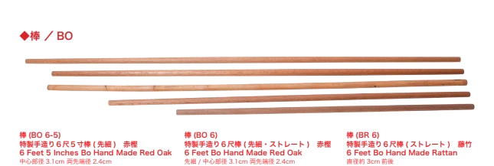

94.1 The bo must be made of hardwood such as oak or ebony, round in shape and without pointed ends.
The bo must be made of hardwood such as oak, ebony or others. The bo must be round in shape and have two recognized modifications: a) round b ) round and conical at the ends. In this case, the diameter of the conical Bo at the ends should not be less than 24 mm. The weight of the BO must be at least 900 gr., For men of categories 18-35, 36-50, 51 and older. For women, the weight of the BO must be at least 800 gr.

94.2 For children and cadets, the length must be one fist above or below the top of the competitor's head.
For children and cadets, the length of the BO must be at least 10 cm higher than their own height.
For juniors and veterans, the standard length is 180 cm (6 ft) or may be one fist above or below the top of the competitor's head.

94.3 The weight of the BO for older and veteran male competitors must be at least 900g.

94.4 The weight of the BO for senior and veteran female participants must be at least 800 g.

94.5 An Ultralight Bo may be disqualified from the competition following a check by the judge.
RKHSK seal/mark is required for all Bo competitors . The stamp/mark will be received after Bo passes the check.
ARTICLE 95: EKU (EKKU)
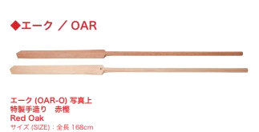

95.1 The ekku must be made of hardwood and have a length that must be between: the height of the competitor's chin to the top of the competitor's head, measured from the floor.

Ekku blade must have a flat side and a rounded or beveled side, and the tip of the blade must not have a sharp point.

95.3 Weight for senior male and veteran competitors must be at least 650g.

95.4 Weight for senior and veteran female competitors must be at least 550g.

95.5 Ultralight Ekku may be disqualified from the competition following a check by the judge.

RKHSK stamp/mark is required for all Ekku members . Stamp/mark received after Ekku passes inspection.

ARTICLE 96: NUNCHAKU

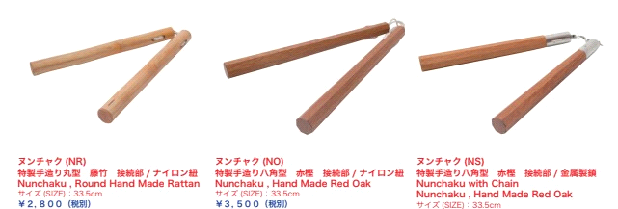

96.1 Nunchaku , consisting of two wooden sticks connected together with a chain, rope or strap. Each piece should be about the length of a forearm when held in a high grip at the top of the shaft. Both ends are the same length and can be rounded or octagonal. All participants must have only wooden nunchucks without any exception.

96.2 In a kata tournament, competitors use only one pair of nunchaku . Kata with two (pairs) are not allowed.

96.3 Sansetsukon are not allowed to enter the tournament. Lighting effects are prohibited in the tournament.

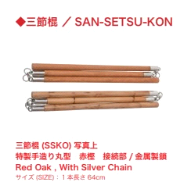

ARTICLE 97: TONFA (pair)
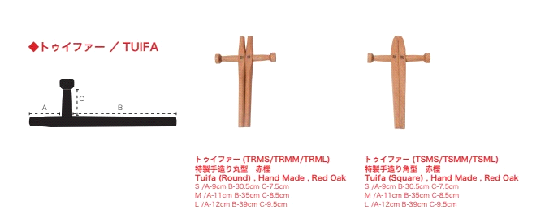

97.1 The TONFA must be made entirely of hardwood with a minimum length when grasped by the handles to reach the end of the competitor's elbow. Various modifications of tonfa are applicable - rectangular, rectangular-oval and round .

97.2 Two TONFAs are used in KOBUDO competitions.

ARTICLE 98: AIS (pair)
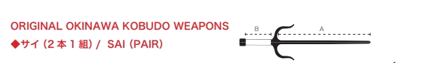
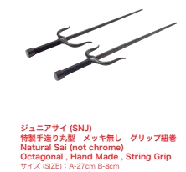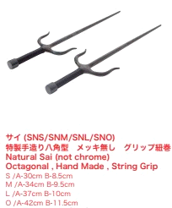

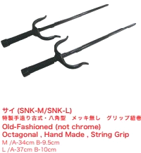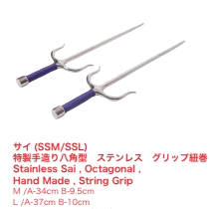
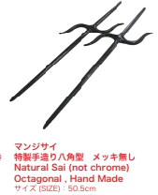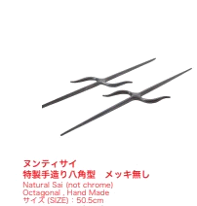

Sais must be used for the Competition (Kata Sai using one Sai or three Sais are not allowed).

98.2 Sai must be made of steel.

98.3 The tip should, in principle, project 1 cm above the competitor's elbow.

Sai weight for senior and veteran male athletes must be at least 650g.

Sai weight for senior and veteran female competitors must be at least 550g.

98.6 The act of throwing Sai or piercing floor by Sai while performing is prohibited.

ARTICLE 99: KAMA (couple)
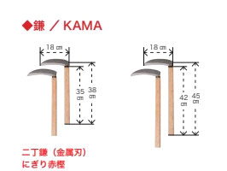

99.1 Two Kamas must be used for the competition.

99.2 The hilts of the Kama shall be of wood and the blades shall be of uncut steel. Ropes, chords , strings, etc. are not allowed, not camas with holes in the blades.
The handles of the Kama should be wooden, and the blades should be made of uncut steel. Also Kama can be completely made of hardwood handle and blade.
99.3 It is forbidden to use Kama with sharp blades and tips, in the category of Children and cadets. The blade of the Kama must be blunted, taped or otherwise secured to prevent injury to the competitor.
In the category of children and cadets, an all-wood kama , made from hardwood, may be used.

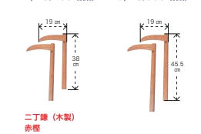

ARTICLE 100: TINBE
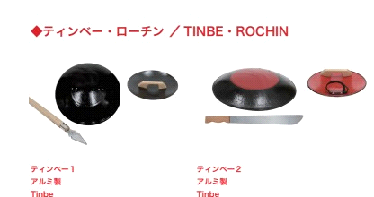

100.1 Tinbe is a combination weapon consisting of a shield and a spear.

100.2 The shield is usually oval or round in shape, about 45-50 cm in diameter, made of steel, aluminum or other tortoise-shell material.

100.3 The Spear of Rochin is usually forearm length from wrist to elbow. It can be crafted with a metal-tipped wooden stick or swords, or an all-metal rounded short stick without a tip, or machete-style metal tools.

100.4 It is forbidden to use spears with sharp blades and tips in the categories of Children and Cadets. In the categories of Children and Cadets, a Rochin made of solid wood is applicable.

ARTICLE 101: GENERAL CONDITIONS
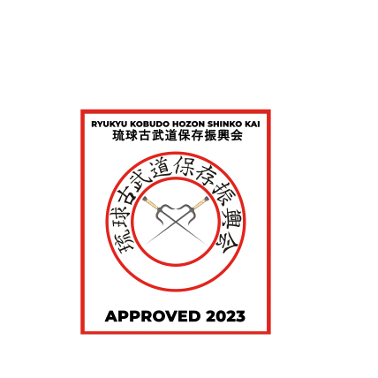
101.1 All weapons must be inspected by an official prior to the start of the competition to ensure they are of genuine design, construction and materials. After inspection, the weapon must be marked.

The participant will be disqualified from the competition
with unmarked weapons.
No official RKHSK marking .

101.2 Any weapon which, in the opinion of the examiner, gives an unfair advantage may not be used. Reasons for refusing weapons include, but are not limited to, light weight, grip coating, markings (including various wood color tones), and custom construction.
101.3 All wood on the weapon must be hard (oak, teak, ebony, mahogany; no rattan ). Exception: Nunchaku can be made from Rattan (Bamboo).

Chapter 25 LIST OF KATA KOBUDO

List of Kobudo kata by Okinawan and Japanese Kobudo styles - attached separately
Application No. 1

OFFICIAL KOBUDO KATA LIST
Kobudo Katas not listed could be used . They must be traditional Okinawa or Japanese based. To be considered they must be submitted prior to the commencement of the completion. This submission must be in writing and will be considered during the kobudo seminar.
Bo (Ku/ Kon ) / Nunti Bo | Ekku / Eku | Nunchaku | Sai | Kama | Tonfa | Tinbe
Kubo no kun | Ekku | Kina no Nunchaku | Sai Ichi No Dan | Kama | Hama Higa no Tonfa | Tinbe
Katin no kun | Matsumura no Ekubo | Maezato ( Miyazato / Taira ) no Nunchaku | Sai Ni No Dan | Kingawa ( Kanegawa ) no Nicho Gama Sho /Dai | Matayoshi no Tonfa 1.2 | Kuniyoshi no Tinbe
Ruru no kun | chikin sunakake | Ogusuku ( Uhugushiku / Kihon ) no Nunchaku | Tawada no Sai Sho ( Mabuni no Sai) | Matayoshi ( Gushikawa) Tairagua no Nichogama ) no Nichogama 1.2 | Yakaa no Tonfa | Kanegawa no Tinbe
Tokumine no Kon / Chatanyara Sho no kon | ( tsukensunakake )  No Ekkubo | Akamine no Nunchaku | Chikinshitahaku ( Tsukenshitahaku ) no Sai | Kishaba no Nichogama | Yara Gua no Tonfa | Daijo (Kama) no Tinbe
Shushi no Kon Sho /Dai | Ufuchiku no Ekubo | Kuniyoshi no Nunchaku 1, 2 | Toyei ( Chatanyara) Sho no Sai | Toyama (Tozan) no Nicho Gama | Matsuhiga no Tonfa | Matayoshi no Tinbe
Yunigawa ( Yonekawa ) no Kon | Tsukenakachu no Ekubo | San bon Nunchaku | Matsumura no Sai | Kina no Nichogama | Kuniba no Tonfa | Tokushin No Tinbe
Sakugawa no Kon | Irei no Ekubo | Nihonunchaku | Chatanyara no Sai | Kuzushi Sho /Dai no Nichogama | Kuzushi Sho /Dai no Tonfa
Sakugawa no Kon Sho /Dai | Akahachi no Ekubo | Denko Nunchaku | Ananku no Sai | Ogusuku ( Uhugushiku ) no Nichogama | Kina no Tonfa
Arakaki no Kon | Yabiko-nago no Ekubo | Shihohai no Nunchaku | Hamahiga no Sai | Soken no Nichogama | Chikina no Tonfa
Shushi ( Suji ) No Kon | Hato no Ekubo | Shinzato no Nunchaku | Arakaki no Sai | Kishaba no Nichogama | Ishimine no Tonfa
Tomari Shirotaru no Kon | Tokushin no E kku | Irei no Nunchaku | Kugusuku ( Kojo ) no Sai | Irei no Nichogama | Kuniba no Tonfa
Shirotaru no Kon |  | Sakagami no Nunchaku | Matsuhiga no Sai | Kuniyoshi no Nichogama | Ufuchiku no Tonfa
Shirotaru no Kon Sho |  |  | Sai San No Dan | Moha Gama (Kama no Ti) | Nakazato no Tonfa
Choun no Kon |  |  | Tawada no Sai
Choun no Kon Sho |  |  | Yakaa no Sai
Sueyoshi ( Shishi ) no Kon |  |  | Jigen no Manji Sai
Soeishi ( Shishi ) no Kon |  |  | Hantagua ( Hakutagawa) Kouragua no Sai
Chinenshikiyanaka no Kon |  |  | Chihara no Sai
Urashi ( Urasoe ) no Kon |  |  | Shinbaru no Sai
Ginowan no Kon |  |  | Jigen no Manjisai
Sesoko no Kon |  |  | Ufuchiku no Nuntesu ( Manjisai )
Chikin ( Tsuken ) Bo (1,2,3) {#designation inconsistent} |  |  | Kishaba no Sai Dai/ Sho
Chatanyara no Kon |  |  | Ufuchiku no Sai
Kongo no Kon |  |  | Kyan no Sai ( Ryuku ) Kenpo )
Hantugua no Kon |  |  | Sai San
Ufutun no Kon |  |  | Kuniyoshi no Sai
Sakiyama no Kon |  |  | Ogusuku / Uhugushiku no Manjisai
Matsuhiga no Kon Sho /Dai |  |  | Shihohai no Sai
Tawada no Kon |  |  | Ishikawaqua no Sai
Ryubi no Kon |  |  | Soken no Sai 1.2
Miyazato no Kon |  |  | Agena no Sai
Kochinda no Kon |  |  | Tokuyama no Sai
Matsukaze no Kon |  |  | Shishiryu ( Kudaka ) no Sai
Rohai no Kon |  |  | Kina no Sai
Shimajiri no Kon Sho /Dai |  |  | Kyan no Sai (Chomo Hanashiro no Sai)
Chikinsunakake ( Tsukensunakake ) no Kon |  |  | Tokushin No Nunti Sai
Matsumura no Kon |  |  | Chotoku Kyan no Sai
Kudaka no Kon
Shihonuki no Kon
Oshiro ( Ogusuku ) no Kon
Sunakake no Kon (Bo 1)
Kashin no Kon ( Kashinbo )
Tsuyoshi no Nuntibo
Uhugushiku ( Ogusuku ) no Nuntibo
Matayoshi no Nuntibo (1.2)
Tokushin no Bo
Tokushin No Nunti Bo no Kon
Tokushin no Yari no Kon

Application №2

OFFICIAL KOBUDO KATA LIST BO ( Roku Shaku )
Kobudo Katas not listed could be used . They must be traditional Okinawa or Japanese based. To be considered they must be submitted prior to the commencement of the completion. This submission must be in writing and will be considered during the kobudo seminar.
No. | Bo (Kun/ Kon ) / Nunti Bo | Originator/Creator | test | KAIHA
1 | Kubo no kun
2 | Katin no kun
3 | Ruru no kun
4 | Tokumine no Kon / Chatanyara Sho no kon
5 | Shushi no Kon Sho / | Moden / _  Jinsei Kamiya | kyu | Ryukyu Kobudo  Hozon Shinko Kai
6 | Sakugawa no Kon Sho / | Moden Yabiku | Sho Dan | RKHSK
7 | Shushi no Kon Dai | Moden Yabiku | Ni Dan | RKHSK
8 | Sakugawa no Kon Dai | Moden Yabiku | San Dan | RKHSK
9 | Yunigawa ( Yonegawa ) no Kon (Left hand) | Moden Yabiku | Yong Dan | RKHSK
10 | Shirataru no Kon | Moden Yabiku | Go Dan | RKHSK
eleven | Choun no Kon | Jinsei Kamiya |  | RKHSK
12 | Chinenshichanaka no Kon | Moden Yabiku |  | RKHSK
13 | Sueyoshi no Kon | Kenwa Mabuni |  | RKHSK
14 | Shishi no Kon | Moden Yabiku |  | RKHSK
15 | Urashi ( Urasoe )  Huntaguwa no Kon | Kenwa Mabuni |  | RKHSK
16 | Chikinsunakake ( Tsukensunakake ) no Kon | Moden Yabiku |  | RKHSK
17 | Sesoko no Kon | Kenwa Mabuni |  | RKHSK
18 | Chikin no Bo | Moden Yabiku |  | RKHSK
19 | Chatanyara no Kon | Jinsei Kamiya |  | RKHSK
20 | Kongo no Kon | Shinken Taira |  | RKHSK
21 | Hantaguwa no Kon | Moden Yabiku |  | RKHSK
22 | Sakugawa no Kon
23
24 | Arakaki no Kon
25 | Shushi ( Suji ) No Kon
26 | Tomari Shirotaru no Kon
27
28 | Shirotaru no Kon Sho
29
30 | Choun no Kon Sho
31 | Sueyoshi ( Shishi ) no Kon
32 | Soeishi ( Shishi ) no Kon
33 | Ginowan no Kon
34 | Chikin ( Tsuken ) Bo (1,2,3) {#designation  inconsistent}
35 | Kongo no Kon
36 | Ufutun no Kon
37 | Sakiyama no Kon
38 | Matsuhiga no Kon Sho /Dai
39 | Tawada no Kon
40 | Ryubi no Kon
41 | Miyazato no Kon
42 | Kochinda no Kon
43 | Matsukaze no Kon
44 | Rohai no Kon
45 | Shimajiri no Kon Sho /Dai
46 | Matsumura no Kon
47 | Kudaka no Kon
48 | Shihonuki no Kon
49 | Oshiro ( Ogusuku ) no Kon
50 | Sunakake no Kon (Bo 1)
51 | Kashin no Kon ( Kashinbo )
52 | Tsuyoshi no Nuntibo
53 | Uhugushiku ( Ogusuku ) no Nuntibo
54 | Matayoshi no Nuntibo (1.2)
55 | Tokushin no Bo
56 | Tokushin No Nunti Bo no Kon
57 | Tokushin no Yari no Kon

Application №3

OFFICIAL KOBUDO KATA LIST EKKU/EKU
Kobudo Katas not listed could be used . They must be traditional Okinawa or Japanese based. To be considered they must be submitted prior to the commencement of the completion. This submission must be in writing and will be considered during the kobudo seminar.
No. | Ekku / Eku | Originator/Creator | test | KAIHA
1 | Ekku
2 | Matsumura no Ekubo
3 | chikin sunakake  ( Tsuken Sunakake no Ekku | Moden Yabiku | Go Dan | RKHSK
4 | ( tsukensunakake )  No Ekkubo
5 | Ufuchiku no Ekubo
6 | Tsukenakachu no Ekubo
7 | Irei no Ekubo
8 | Akahachi no Ekubo
9 | Yabiko-nago no Ekubo
10 | Hato no Ekubo
11 | Tokushin no eku

Application No. 4

OFFICIAL KOBUDO KATA LIST NUNCHAKU
Kobudo Katas not listed could be used . They must be traditional Okinawa or Japanese based. To be considered they must be submitted prior to the commencement of the completion. This submission must be in writing and will be considered during the kobudo seminar.
No. | Nunchaku | Originator/Creator | test | KAIHA
1 | Kina no Nunchaku
2 | Maezato ( Miyazato / Taira ) no Nunchaku | Shinken Taira | kyu | RKHSK
3 | Akamine no Nunchaku | Eisuke Akamine | Sho Dan | RKHSK
4 | San bon Nunchaku |  |  | RKHSK
5 | Ogusuku ( Uhugushiku / Kihon )  no Nunchaku
6 | Kuniyoshi no Nunchaku 1, 2
7 | Nihonunchaku
8 | Denko Nunchaku
9 | Shihohai no Nunchaku
10 | Shinzato no Nunchaku
eleven | Irei no Nunchaku
12 | Sakagami no Nunchaku

Application No. 5

OFFICIAL KOBUDO KATA LIST SAI
Kobudo Katas not listed could be used . They must be traditional Okinawa or Japanese based. To be considered they must be submitted prior to the commencement of the completion. This submission must be in writing and will be considered during the kobudo seminar.
No. | Sai | Originator/Creator | test | KAIHA
1 | Sai Ichi No Dan
2 | Sai Ni No Dan
3 | Tawada no Sai Sho ( Mabuni no Sai)
4 | Chikinshitahaku ( Tsukenshitahaku ) no Sai | Moden Yabiku | Sho Dan | RKHSK
5 | Chatanyara no Sai | Jinsei Kamiya | Ni Dan | RKHSK
6 | Hamahiga no Sai | Kenwa Mabuni  Jinsei Kamiya | San Dan | RKHSK
7 | Kugusuku ( Kojo ) no Sai |  | Yong Dan | RKHSK
8 | Tawada (Tada) no Sai | Moden Yabiku | Go Dan | RKHSK
9 | Yaka no Sai |  |  | RKHSK
10 | Manji no Sai ( Jigen ) |  |  | RKHSK
eleven | Hantagwa no Sai | Kenwa Mabuni |  | RKHSK
12 | Toyei ( Chatanyara) Sho no Sai
13 | Matsumura no Sai
14 | Ananku no Sai
15 | Arakaki no Sai
16 | Matsuhiga no Sai
17 | Sai San No Dan
18 | Jigen no Manji Sai
19 | Hantagua ( Hakutagawa) Kouragua no Sai
20 | Chihara no Sai
21 | Shinbaru no Sai
22 | Jigen no Manjisai
23 | Ufuchiku no Nuntesu ( Manjisai )
24 | Kishaba no Sai Dai/ Sho
25 | Ufuchiku no Sai
26 | Kyan no Sai ( Ryuku ) Kenpo )
27 | Sai San
28 | Kuniyoshi no Sai
29 | Ogusuku / Uhugushiku no Manjisai
30 | Shihohai no Sai
31 | Ishikawaqua no Sai
32 | Soken no Sai 1.2
33 | Agena no Sai
34 | Tokuyama no Sai
35 | Shishiryu ( Kudaka ) no Sai
36 | Kina no Sai
37 | Kyan no Sai (Chomo Hanashiro no Sai)
38 | Tokushin No Nunti Sai
39 | Chotoku Kyan no Sai

Application No. 6

OFFICIAL KOBUDO KATA LIST TUNFA
Kobudo Katas not listed could be used . They must be traditional Okinawa or Japanese based. To be considered they must be submitted prior to the commencement of the completion. This submission must be in writing and will be considered during the kobudo seminar.
No. | Tonfa | Originator/Creator | test | KAIHA
1 | Hama Higa no Tunfa | Moden Yabiku | Ni Dan | RKHSK
2 | Yara Gwa no Tunfa | Moden Yabiku |  | RKHSK
3 | Matayoshi no Tonfa 1.2
4 | Yakaa no Tonfa
5 | Matsuhiga no Tonfa
6 | Kuniba no Tonfa
7 | Kuzushi Sho /Dai no Tonfa
8 | Kina no Tonfa
9 | Chikina no Tonfa
10 | Ishimine no Tonfa
11 | Kuniba no Tonfa
12 | Ufuchiku no Tonfa
13 | Nakazato no Tonfa

Application No. 7

OFFICIAL KOBUDO KATA LIST KAMA
Kobudo Katas not listed could be used . They must be traditional Okinawa or Japanese based. To be considered they must be submitted prior to the commencement of the completion. This submission must be in writing and will be considered during the kobudo seminar.
No. | Kama | Originator/Creator | test | KAIHA
1 | Kama
2 | Kanegawa no Nicho Gama | Kanegawa Gibu | Yong Dan | RKHSK
3 | Toyama (Tozan) no Ni Cho Gama |  |  | RKHSK
4 | Kingawa ( Kanegawa ) no Nicho Gama Sho /Dai
5 | Matayoshi ( Gushikawa) Tairagua no Nichogama ) no Nichogama 1.2
6 | Kishaba no Nichogama
7 | Kina no Nichogama
8 | Kuzushi Sho /Dai no Nichogama
9 | Ogusuku ( Uhugushiku ) no Nichogama
10 | Soken no Nichogama
11 | Kishaba no Nichogama
12 | Irei no Nichogama
13 | Kuniyoshi no Nichogama
14 | Moha Gama (Kama no Ti)

Application No. 8

OFFICIAL KOBUDO KATA LIST TINBE
Kobudo Katas not listed could be used . They must be traditional Okinawa or Japanese based. To be considered they must be submitted prior to the commencement of the completion. This submission must be in writing and will be considered during the kobudo seminar.
No. | Tinbe | Originator/Creator | test | KAIHA
1 | Tinbe
2 | Kuniyoshi no Tinbe
3 | Kanegawa no Tinbe | Kanegawa Gibu | San Dan | RKHSK
4 | Daijo (Kama) no Tinbe
5 | Matayoshi no Tinbe
6 | Tokushin No Tinbe

